What I did this week:

1. Re-do the tests on: 2 cameras; using the least squares to find the optimal homography.
2. Try to (dis)prove that the least squares method will work for 2 cameras
3. Find some literature on “Adaptive structured lighting”

I found this paper (also attached in the email), but I’m not sure if this is what we need:

<http://klab2.ibe.kagoshima-u.ac.jp/papers/2007_2009/3-1/7-cvpr08final.pdf>

1. In the previous tests, the chessboard corners were not detected correctly, so we were not sure if the results weren’t nice because of the least squares, or the chessboard detection.

I tested the 2-camera + least squares again, making sure that the chessboard is detected correctly. However, the least squares method is not doing a great job: the anamorphosis is almost perfectly straight for 1 camera, but very distorted for the other camera.

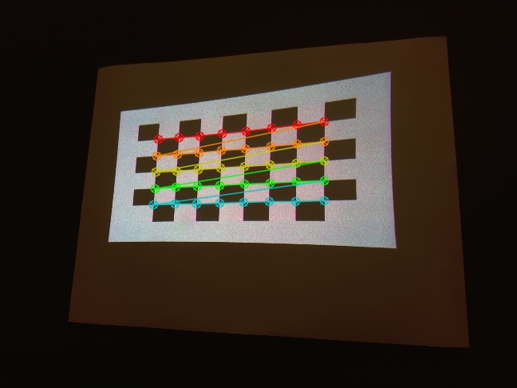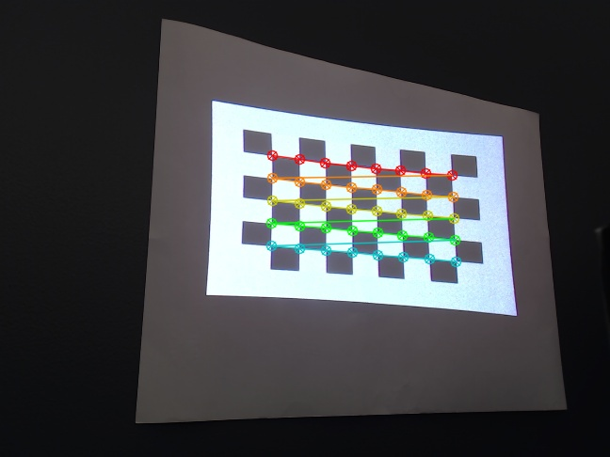

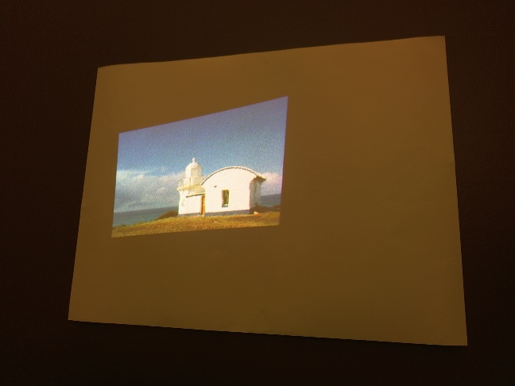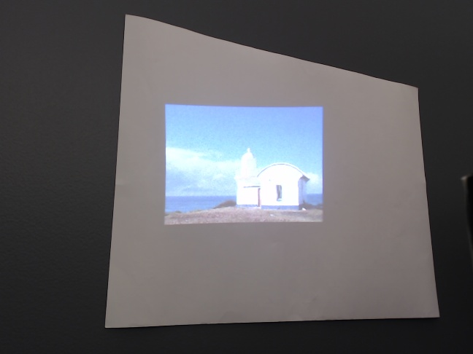

camera 1 camera 2